PART III

SOLUTIONS TO REVIEW QUESTIONS

AND EXERCISES

FOR PART 4 – METHODOLOGY (CHAPTERS 14 – 17)
Solutions to Review Questions and Exercises

Chapter 14 Methodology - Conceptual Database Design 3
Chapter 15 Methodology - Logical Database Design for Relational Model 13
Chapter 16 Methodology - Physical Database Design for Relational Databases 23
Chapter 17 Methodology – Monitoring and Tuning the Operational System 28

Chapter 14 Methodology - Conceptual Database Design

Review Questions

14.1 Describe the purpose of a design methodology.

A structured approach that uses procedures, techniques, tools, and documentation aids, to support and facilitate the process of design. A design methodology consists of phases that contain steps, which guide the designer in the choice of techniques that are appropriate at each stage of the project and also helps to plan, manage, control and evaluate database development projects. Furthermore, it is a structured approach for analyzing and modeling a set of requirements for a database in a standardized and organized manner.

See Section 14.1.

14.2 Describe the main phases involved database design.

Conceptual database design – to build the conceptual representation of the database, which includes identification of the important entities, relationships, and attributes.
Logical database design – to translate the conceptual representation to the logical structure of the database, which includes designing the relations.
Physical database design – to decide how the logical structure is to be physically implemented (as relations) in the target Database Management System (DBMS).

See Section 14.1.2 for complete definitions.

14.3 Identify important factors in the success of logical database design.

- Work interactively with the users as much as possible
- Follow a structured methodology throughout the data modeling process
- Employ a data-driven approach
- Incorporate structural and integrity considerations into the data models
- Combine conceptualization, normalization, and transaction validation techniques into the data modeling methodology
- Use diagrams to represent as much of the data models as possible
- Use a Database Design Language (DBDL) to represent additional data semantics that cannot easily be represented in a diagram
- Build a data dictionary to supplement the data model diagrams and the DBDL
- Be willing to repeat steps.

See Section 14.1.3.

14.4 Discuss the important role played by users in the process of database design.

The users’ involvement throughout the database design phase is critical to providing the ‘correct’ system. In particular, the user should clarify any ambiguities in the specification that describes the required system and also review continually the development of the database design. The process of developing the database design is repeated until the user is prepared to ‘sign-off’ the design as being a ‘true’ representation of the part of the enterprise that is being modeling.

See Sections 14.1.3 and 14.2 (Step 1.9).

14.5 Describe the main objective of conceptual database design.

See Section 14.3 Step 1.

14.6 Identify the main steps associated with conceptual database design.

See start of Section 14.3 Step 1.

14.7 How would you identify entity and relationship types from a user’s requirements specification?

One method of identifying entities is to examine the users’ requirements specification. From this specification, we identify nouns or noun phrases that are mentioned (for example, staff number, staff name, property number, property address, rent, number of rooms). We also look for major objects such as people, places, or concepts of interest, excluding those nouns that are merely qualities of other objects. (See Step 1.1)

Having identified the entities, the next step is to identify all the relationships that exist between these entities. When we identify entities, one method is to look for nouns in the users’ requirements specification. Again, we can use the grammar of the requirements specification to identify relationships. Typically, relationships are indicated by verbs or verbal expressions. (See Step 1.2)

14.8 How would you identify attributes from a user’s requirements specification and then associate the attributes with entity or relationship types?

In a similar way to identifying entities, we look for nouns or noun phrases in the users’ requirements specification. The attributes can be identified where the noun or noun phrase is a property, quality, identifier, or characteristic of one of these entities or relationships. By far the easiest thing to do when we have identified an entity (x) or a relationship (y) in the requirements specification is to consider What information are we required to hold on x or y? The answer to this question should be described in the specification. However, in some cases it may be necessary to ask the users to clarify the requirements. Unfortunately, they may give answers to this question that also contain other concepts, so that the users’ responses must be carefully considered.

As there are generally many more attributes than entities and relationships, it may be useful to first produce a list of all attributes given in the users’ requirements specification. As an attribute is associated with a particular entity or relationship, remove the attribute from the list. In this way, we ensure that an attribute is associated with only one entity or relationship type and, when the list is empty, that all attributes are associated with some entity or relationship type.

14.9 Describe the purpose of specialization/generalization of entity types, and discuss why this is an optional step in conceptual database design.

See Section 14.3 Step 1.6.

14.10 How would you check a data model for redundancy? Give an example to illustrate your answer.

(1) Re-examine one-to-one (1:1) relationships
In the identification of entities, we may have identified two entities that represent the same object in the enterprise. For example, we may have identified the two entities Client and Renter that are actually the same; in other words, Client is a synonym for Renter. In this case, the two entities should be merged together. If the primary keys are different, choose one of them to be the primary key and leave the other as an alternate key.

(2) Remove redundant relationships
A relationship is redundant if the same information can be obtained via other relationships. We are trying to develop a minimal data model and, as redundant relationships are unnecessary, they should be removed. It is relatively easy to identify whether there is more than one path between two entities. However, this does not necessarily imply that one of the relationships is redundant, as they may represent different associations between the entities.

Section Section 14.3 Step 1.7.

14.11 Discuss why you would want to validate a conceptual data model and describe two approaches to validating a conceptual model.

We validate a conceptual data model to check the model to ensure that the model supports the transactions required by this view. Using the model, we attempt to perform the operations manually. If we can resolve all transactions in this way, we have checked that the conceptual data model supports the required transactions. However, if we are unable to perform a transaction manually there must be a problem with the data model, which must be resolved. In this case, it is likely that we have omitted an entity, a relationship, or an attribute from the data model.

Two possible approaches to ensuring that the local conceptual data model supports the required transactions are:
(1) describing the transactions;
(2) using transaction pathways.

See Section 14.3 Step 1.8.

14.12 Identify and describe the purpose of the documentation generated during conceptual database design.

See Section 14.3 and in particular note the documentation generated at the end of each step.

Exercises

The DreamHome case study

14.13 Create a local conceptual data model for the Branch view of DreamHome documented in Appendix A. Compare your ER diagram with Figure 12.8 and justify any differences found.

Student should create an ER diagram similar to Figure 12.8. Some acceptable differences may be:
- Specialization of Staff into Supervisor and Manager may not have been identified (in which case, Manages relationship will be between Staff and Branch). Similarly, specialization of Owner into PrivateOwner and BusinessOwner may not have been identified.
- The ternary relationship Registers may have been identified instead as an entity, Registration, with relationships to Staff, Client, and Branch.

14.14 Show that all the query transactions for the Branch view of DreamHome listed in Appendix A are supported by your local conceptual data model.

Students can use either of the approaches described in Step 1.8 (describing the transactions or using transaction pathways). In either case, the students should be able to show that the query transactions are supported by their local conceptual data model.

The University Accommodation Office case study

14.15 Provide a user’s requirements specification for the University Accommodation Office case study documented in Appendix B.1.

This should be a relatively straightforward task for the student, due to the way the case study has been specified.

14.16 Create a local conceptual data model for the one user view. State any assumptions necessary to support your design. Check that the local conceptual data model supports the required transactions.
Advises
Requests
Provides
Lease
leaseNo
Hall
hallNo
Room
placeNo

Flat
flatNo
Student
bannerNo
1..1
1..*
Staff
staffNo
0..*
1..1
1..*
1..1
For
1..1
1..*
Manages
0..1
1..1
Has
FlatInspection

1..1
1..*
Makes
NOK
bannerNo

1..1
0..*
HasNOK
0..1
1..1
Generates
Invoice
invoiceNo
1..1
1..1

Accommodation

ResidenceStaff
staffNo

Using either a description of the transactions listed in Appendix B.1.2 or using a transaction pathway diagram, the student should show that his/her model supports these transactions.

The EasyDrive School of Motoring case study

14.17 Provide a user’s requirements specification for the EasyDrive School of Motoring case study documented in Appendix B.2.

This should be a relatively straightforward task for the student, due to the way the case study has been specified.

14.18 Create a local conceptual data model for the one user view. State any assumptions necessary to support your design. Check that the local conceptual data model supports the required transactions.
1..1
Staff

staffNo {PK}
fName
lname
sAddress
jobTitle
salary
NIN
sex
dob

Client

clientNo {PK}
cAddress
cPostcode
cTelNo
dLicenseNo
sex
dob
Lesson

lessonNo {PK}
lessonDate
lessonTime
stage
progress
comments
mileageStart
mileageFinish

Vehicle

vehRegNo {PK}
model
make
color
capacity
Inspection

inspDate
inspTime
faultsFound
comments
Office

officeNo {PK}
oAddress
oPostcode
oTelNo
oFaxNo

Interview

iDate
iTime
iRoom
iComments
dLicense
Manages
RequiredFor
Has
Books
Undertakes
0..1
1..*
1..1
1..1
0..*
1..1
1..1
0..*
1..1
1..*
1..*
InspectedBy
Registers
0..*
1..1
Attends
Requests
Takes
1..1
1..1
0..*
1..1
1..1
DrivingTest

testNo {PK}
testDate
testTime
testCentre
testerName
attempt
result
pTestComment
tTestMark
tTestComments

0..*
Sits
1..1
1..*
1..1
1..*
Runs

Using either a description of the transactions listed in Appendix B.2.2 or using a transaction pathway diagram, the student should show that his/her model supports these transactions.
The Wellmeadows Hospital case study

14.19 Identify user views for the Medical Director and Charge Nurse in the Wellmeadows Hospital case study described in Appendix B.3.

See next questions.

14.20 Provide a user’s requirements specification for each of these user views.

The student should examine the case study in detail and identify and compile a user specification for the Medical Director’s and the Charge Nurse’s views. As an additional task the student may also compile a specification for the Personnel Officer’s view.

Of course, to complete this exercise will require that the student makes some assertions about the precise requirements of each user view. Any assumption should be documented along with each view.

Examples of specification for the Medical Director’s and Charge Nurse’s views are shown below.

Medical Director
The Director is responsible for the overall management of the hospital and must maintain control over the use of resources (including staff, beds, and supplies) in the provision of cost-effective treatment for all patients.

1. The hospital is composed of many wards. Each ward is managed by a Charge Nurse. The information to be held on each ward includes the ward name, number (e.g. W1), phone number, location (e.g. Block E), number of beds, and the name of the Charge Nurse.

2. Each ward is allocated staff including (e.g. Charge nurse, senior and junior nurses, doctors, consultants, auxiliaries).

3. The hospital maintains a central stock of surgical (e.g. syringe, bandages) and non-surgical (e.g. plastic bags, aprons). The details of surgical and non-surgical supplies includes item number and name, item description, quantity in stock, re-order level, cost per unit. The supplies used by each ward are monitored.

The hospital also maintains a stock of pharmaceutical supplies (e.g. antibiotics, pain killers). The details of pharmaceutical supplies includes drug number and name, description, dosage, quantity in stock, re-order level, cost per unit. The pharmaceutical supplies used by each ward are monitored.

4. The details of the suppliers of the surgical, non-surgical and pharmaceutical items are stored. The information stored includes the supplier name and number, address, phone and fax number.

5. Patients are normally referred to the hospital for treatment by their local doctor. The details of local doctors are stored including their name, clinic number, address, and phone number.

6. The details of patients referred to the hospital includes the patient number, name (first and last name), address, phone number, date of birth, martial status, and next-of-kin details (name, relationship, address, and phone number).

7. When a patient is referred by his/her doctor to attend the hospital, the patient is given an appointment and is examined by a consultant. The details of the appointment are stored including the consultant’s name and number, appointment number, date and time, and examination room (e.g. Room E112).

As a result of the examination, the patient is either recommended to attend the outpatient clinic or placed on a waiting list until a bed can be found in a particular ward.

8. The details of outpatients are stored. The information stored includes the patient details as stated earlier (see 6) and the date and time of the appointment at the outpatient clinic.

9. The details of patients currently placed in a ward and those on the waiting list for a place on a ward are stored. The information stored includes the patient details as stated earlier (see 6) and the date placed on waiting list, ward required, expected duration of stay, date placed in the ward, and date left the ward.

Charge Nurse
The Charge Nurse has overall responsibility for the management of a single ward. The Charge Nurse is allocated a budget to run the ward and must ensure that all resources (staff, beds and supplies) are used effectively in the care of patients.

The Charge Nurse and other senior medical staff are responsible for the allocation of beds to patients on the waiting list.

1. The information to be held on each ward includes the details of staff allocated to each ward including the staff number, name, address, phone number, position, and number of hours worked per week and shift (e.g. early, late).

2. The information stored on each patient on the waiting list includes the patient number, name (first and last name), address, phone number, date of birth, martial status, next-of-kin details, date placed on waiting list, required ward, date placed in ward, expected duration of stay, and date left ward.

3. When a patient enters the ward they are allocated a bed with a unique bed number. Each patient is prescribed medication and the details of this medication includes the patient number, drug number and name, units per day, start and finish date. The medication (pharmaceutical supplies) given to each patient is monitored.

4. Staff are allocated to work in wards, as required. The Charge Nurse of each ward is responsible for creating a staff rota, which ensures that the correct complement of staff are on duty for each shift (early, late, night). Nursing staff may be specifically allocated to patients who required specialist care.

5. When required the Charge Nurse may obtain surgical, non-surgical and pharmaceutical supplies from the central stock of supplies held by the hospital. The information to be stored includes the requisition number, staff name and number, ward number, item number (or drug number), quantity required, date ordered and date received.

14.21 Create local conceptual data models for each of the user views. State any assumptions necessary to support your design.

The student should create local conceptual data models using the requirements specification for the Medical Director and the Charge Nurse. This should include an ER model representing each user view and the supporting documentation that describes the models. Throughout the process of design, the student should clearly state any assumptions necessary to support his or her design.

Below is a conceptual data model for the two views combined.

dd
Attends
Refers
RelatedTo
Takes
Forms
In
WorksIn
Is
GoesTo
Examines
Makes
For
AssignedTo
Receives
Provides
HasQual
Doctor

Clinic
clinicNo
NOK

Item
itemNo
Medication

Drug
drugNo
Ward
wardNo
Staff
staffNo
Requisition
reqNo
Patient
patNo
Supplier
supplierNo
1..1
1..*
0..1
0..*
1..1
1..1
1..*
Bed

OPClinic

Appointment
appNo
Contains
1..1
1..*
Supply

1..1
1..1
0..*
Has
1..1
1..*
InPatient

1..1
1..*
1..*
1..1
1..1
1..*
1..1
1..*
1..1
0..*
Qualification

WorkExp

1..1
0..*
1..1
0..*
1..*
0..*
HasExp
1..1
0..*
0..*
1..1
0..*
1..1
1..*
0..*
WorksIn
0..*
1..*
ChargeFor
0..1
1..1

Chapter 15 Methodology - Logical Database Design for Relational Model

Review Questions

15.1 Discuss the purpose of logical database design.

For the purpose of logical database design see Section 15.1.

15.2 Describe the types of structures that are known not to be compatible with the relational model and describe how they could be removed from a conceptual data model. Give examples to illustrate your answer.

Remove: many-to-many (*:*) binary relationship types; many-to-many (*:*) recursive relationship types; complex relationship types; multi-valued attributes. Removal results in the creation of a new entity and corresponding relationships (see Step 2.1).

15.3 Describe the rules for deriving relations that represent:
- strong entity types;
- weak entity types;
- one-to-many (1:*) binary relationship types;
- one-to-one (1:1) binary relationship types;
- one-to-one (1:1) recursive relationship types;
- superclass/subclass relationship types;
- many-to-many (*:*) binary relationship types;
- complex relationship types;
- multi-valued attributes.

See Table 15.2 below.
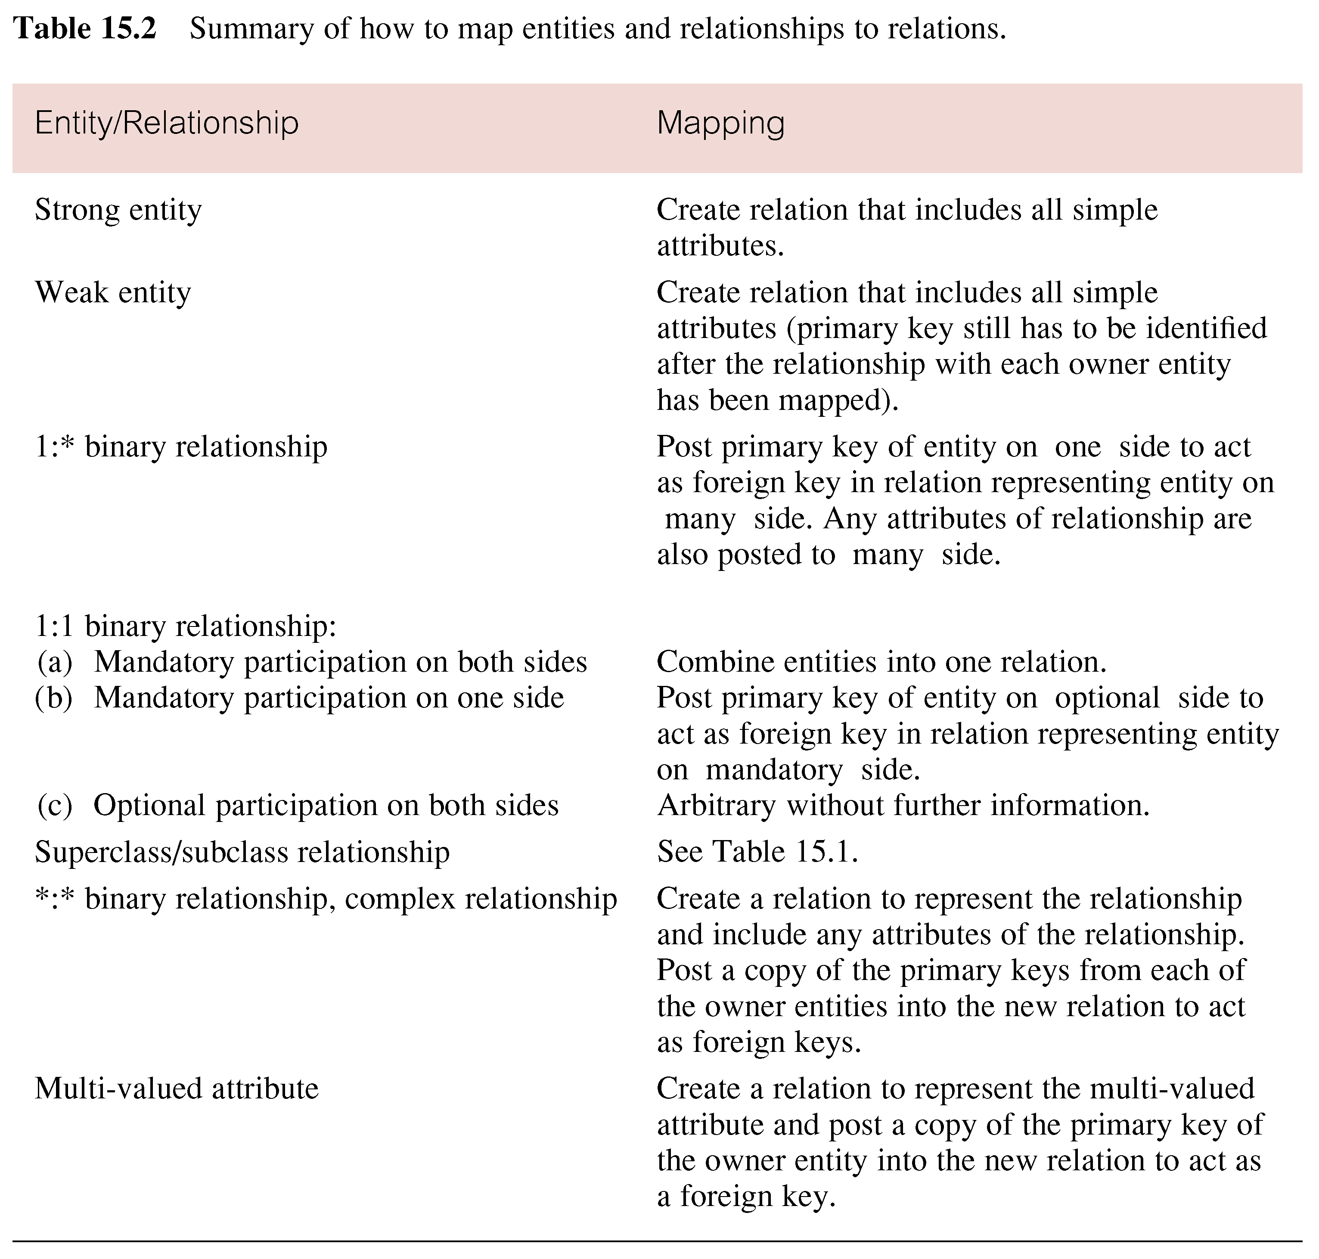

15.4 Discuss how the technique of normalization can be used to validate the logical data model and the relations derived from the model.

The logical data model can be validated using the technique of nomalization and against the transactions that the model is required to support. Normalization is used to improve the model so that it satisfies various constraints that avoid unnecessary duplication of data. Normalization ensures that the resultant model is a closer model of the enterprise that it serves, it is consistent, and has minimal redundancy and maximum stability.

See also Section 15.1 Step 2.3.

15.5 Discuss two approaches that can be used to validate that the logical data model is capable of supporting the transactions required by the user’s view.

Two possible approaches to ensure that the logical data model supports the required transactions include: checking that all the information (entities, relationships and their attributes) required by each transaction is provided by the model in documenting a description of each transaction’s requirements, and diagrammatically representing the pathway taken by each transaction directly on the ER diagram.

See also Section 15.1 Step 2.4.

15.6 Describe the purpose of integrity constraints and identify the five main types of constraints.

The main types of constraints include: There are five types of integrity constraints: required data, attribute domain constraints, entity integrity, referential integrity, and enterprise constraints.

See also Section 15.1 Step 2.6.

15.7 Describe the alternative strategies that can be applied if there exists a child occurrence referencing a parent occurrence that we wish to delete.

There are several strategies to consider when there exists a child occurrence referencing the parent occurrence that we are attempting to delete: NO ACTION, CASCADE, SET NULL, SET DEFAULT, and NO CHECK.

See also Section 15.1 Step 2.6.

15.8 Identify the tasks typically associated with merging local logical data models into a global logical model.

See Section 15.1 Step 3 and in particular Step 3.1.

Exercises

15.9 Derive relations for the following conceptual data model:

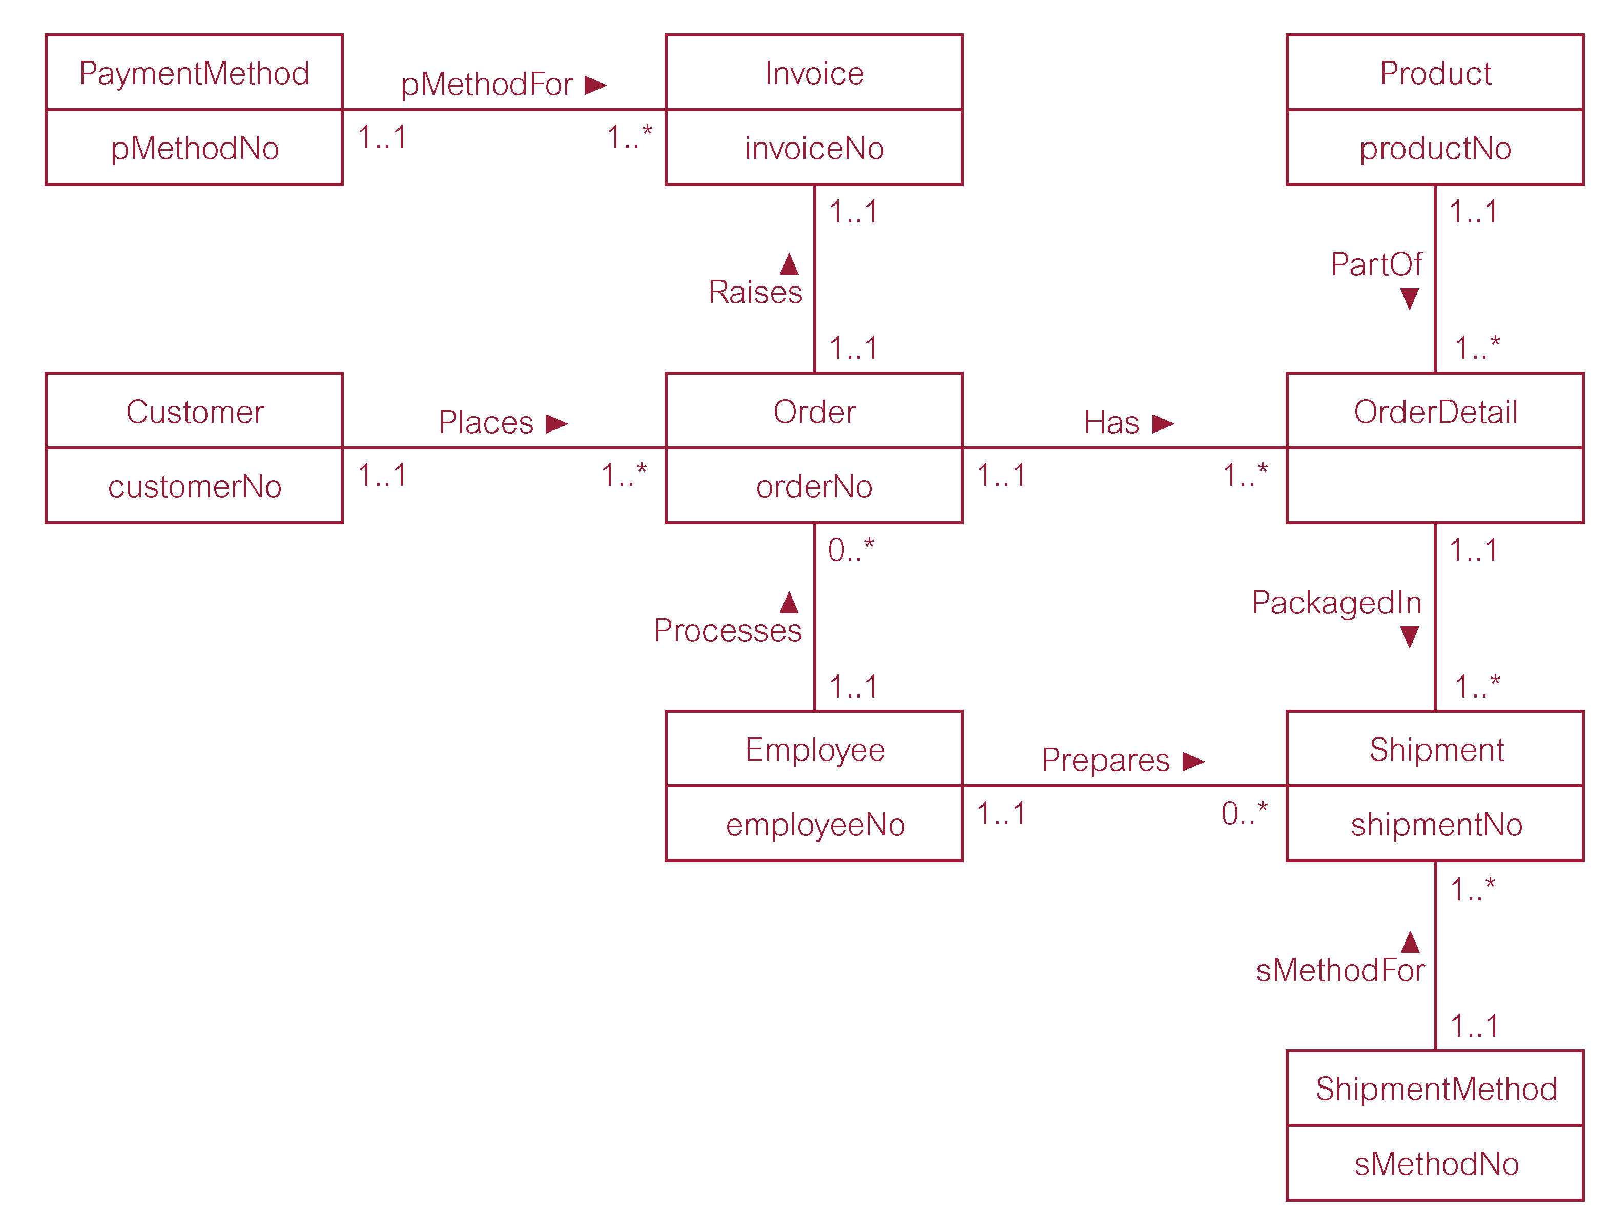

Customer (customerNo, customerName, customerStreet, customerCity,
customerState, customerZipCode, custTelNo, custFaxNo, DOB,
maritalStatus, creditRating)
Primary Key customerNo
Alternate Key custTelNo
Alternate Key custFaxNo

Employee (employeeNo, title, firstName, middleName, lastName, address, workTelExt, homeTelNo, empEmailAddress, socialSecurityNumber, DOB, position, sex, salary, dateStarted)
Primary Key employeeNo
Alternate Key socialSecurityNumber

Invoice (invoiceNo, dateRaised, datePaid, creditCardNo, holdersName, expiryDate,
orderNo, pMethodNo)
Primary Key invoiceNo
Foreign Key orderNo references Order(orderNo)
Foreign Key pMethodNo references PaymentMethod(pMethodNo)

Order (orderNo, orderDate, billingStreet, billingCity, billingState, billingZipCode, promisedDate, status, customerNo, employeeNo)
Primary Key orderNo
Foreign Key customerNo references Customer(customerNo)
Foreign Key employeeNo references Employee(employeeNo)

OrderDetail (orderNo, productNo, quantityOrdered)
Primary Key orderNo, productNo
Foreign Key orderNo references Order(orderNo)
Foreign Key productNo references Product(ProductNo)

PaymentMethod (pMethodNo, paymentMethod)
Primary Key pMethodNo

Product (productNo, productName, serialNo, unitPrice, quantityOnHand, reorderLevel, reorderQuantity, reorderLeadTime)
Primary Key productNo
Alternate Key serialNo

Shipment (shipmentNo, quantity, shipmentDate, completeStatus, orderNo, productNo, employeeNo, sMethodNo)
Primary Key shipmentNo
Foreign Key orderNo, productNo references OrderDetail(orderNo, productNo)
Foreign Key employeeNo references Employee(employeeNo)
Foreign Key sMethodNo references ShipmentMethod(sMethodNo)

ShipmentMethod (sMethodNo, shipmentMethod)
Primary Key sMethodNo

The DreamHome case study
15.10 Create a relational schema for the Branch view of DreamHome based on the conceptual data model produced in Exercise 14.13 and compare your schema with the relations listed in Figure 15.9. Justify any differences found.

Student should produce a relational schema similar to Figure 15.9. May possibly have PrivateOwner and BusinessOwner as a single relation (although this would result in a relation with a lot of nulls). May also not have identified Staff and Manager as distinct relations.

The University Accommodation Office case study
15.11 Create and validate a local logical data model from the local conceptual data model for the University Accommodation Office case study created in Exercise 14.16.

Student (matricNo, fName, lName, street, city, postcode, DOB, sex, category, nationality, smoker, special needs, comments, status, courseNo)
Primary Key matricNo
Foreign Key courseNo references Course(courseNo)

NOK (matricNo, name, street, city, postcode, contactTelNo)
Primary Key matricNo
Foreign Key matricNo references Student(matricNo)

Course (courseNo, courseTitle, courseLeader, courseLeaderTelNo,
courseLeaderRoomNo, deptName)
Primary Key courseNo
Alternate Key courseTitle

Hall (halINo, hName, hAddress, hTeINo, mgrStaffNo)
Primary Key nalINo
Alternate Key hName
Alternate Key hTelNo
Foreign Key mgrStaffNo references Staff(staffNo)

Flat (flatNo, fAddress, noOfRooms)
Primary Key flatNo

Room (placeNo, roomNo, monthlyRent, flatNo, hallNo)
Primary Key placeNo
Foreign Key halINo references Hall(hallNo)
Foreign Key flatNo references Flat(flatNo)

Flatlnspection (flatNo, iDate, condition, comments, inspStaffNo)
Primary Key flatNo, iDate
Foreign Key flatNo references Flat(flatNo)
Foreign Key inspStaffNo references Staff(staffNo)

Lease (leaseNo, duration, matricNo, placeNo, dateEnter, dateLeave)
Primary Key leaseNo
Alternate Key placeNo, dateEnter
Alternate Key matricNo, dateEnter
Foreign Key matricNo references Student(matricNo)
Foreign Key placeNo references Room(placeNo)

AccommStaff (staffNo, fName, lName, street, city, postcode, DOB, sex, position,
location)
Primary Key staffNo
Foreign Key location references Hall(halINo)

Invoice (invoiceNo, semester, paymentDue, datePaid, paymentMethod,
dateReminder1, dateReminder2, leaseNo)
Primary Key invoiceNo
Foreign Key leaseNo references Lease(leaseNo)

The EasyDrive School of Motoring case study
15.12 Create and validate a local logical data model from the local conceptual data model for the EasyDrive School of Motoring case study created in Exercise 14.18.

Office (officeNo, oAddress, oPostcode, oTelNo, oFaxNo, mgrStaffNo)
Primary Key officeNo
Alternate Key oPostcode
Alternate Key oTelNo
Alternate Key oFaxNo
Foreign Key mgrStaffNo references Staff(staffNo)

Staff (staffNo, fName, lname, sAddress, jobTitle, salary, NIN, sex, dob, officeNo)
Primary Key staffNo
Alternate Key NIN
Foreign Key officeNo references Office(officeNo)

Inspection(staffNo, inspDate, inspTime, faultsFound, comments)
Primary Key staffNo, inspDate, inspTime
Foreign Key staffNo references Staff(staffNo)

Vehicle(vehRegNo, model, make, color, capacity, officeNo)
Primary Key vehRegNo
Foreign Key officeNo references Office(officeNo)

Client(clientNo, cPostcode, cTelNo, dLicenseNo, sex, dob, officeNo)
Primary Key clientNo
Alternate Key dLicenseNo
Foreign Key officeNo references Office(officeNo)

Interview(staffNo, iDate, iTime, iRoom, iComments, clientNo)
Primary Key staffNo, iDate, iTime
Foreign Key clientNo references Client(clientNo)

Lesson(lessonNo, lessonDate, lessonTime, stage, progress, comments,
mileageStart, mileageFinish, staffNo, clientNo, vehRegNo)
Primary Key officeNo
Foreign Key staffNo references Staff(staffNo)
Foreign Key clientNo references Client(clientNo)
Foreign Key vehRegNo references Vehicle(vehRegNo)

DrivingTest(testNo, testDate, testTime, testCentre, testerName, attempt, result,
pTestComment, tTestMark, tTestComments, clientNo, vehRegNo)
Primary Key testNo
Alternate Key clientNo, testDate
Alternate Key vehRegNo, testDate, testTime
Alternate Key testerName, testDate, testTime
Foreign Key clientNo references Client(clientNo)
Foreign Key vehRegNo references Vehicle(vehRegNo)

The Wellmeadows Hospital case study
15.13 Create and validate the local logical data models for each of the local conceptual data models of the Wellmeadows Hospital case study identified in Exercise 14.21.

The student should refine the local conceptual models to create local logical data models based on the Medical Director and Charge Nurse views. The logical models representing each user view should also be validated. The student should produce an ER model for each user view and the supporting documentation that describes each model. Throughout the process of design, the student should clearly state any assumptions necessary to support his or her design.

15.14 Merge the local data models to create a global logical data model of the Wellmeadows Hospital case study. State any assumptions necessary to support your design.

Once the local data models have been validated, the student should demonstrate the view integration approach to create a global logical data model. The student should produce an ER model of the global data model, representing both user views and the supporting documentation that describes the model. Throughout the process of design, the student should clearly state any assumptions necessary to support his or her design.

An example of an ER model and the relational schema of the global data model of the Wellmeadows Hospital case study is shown below. Note that this answer also includes the Personnel Officer’s view.

Ward (wardNo, wardName, location, totalBeds, telExtn, chargeNurseStaffNo)
Primary Key wardNo
Alternate Key telExtn
Foreign Key chargeNurseStaffNo NOT NULL references Staff(staffNo)
ON DELETE SET DEFAULT ON UPDATE CASCADE

Staff (staffNo, fName, lName, address, telNo, DOB, sex, NIN, position, salary, sScale, weekHrs, contType, typePay)
Primary Key staffNo
Alternate Key NIN

Qualification (staffNo, oType, oDate, institutionName)
Primary Key staffNo, oType
Foreign Key staffNo NOT NULL references Staff(staffNo) ON DELETE CASCADE
ON UPDATE CASCADE

WorkExperience (staffNo, sDate, fDate, position, orgName)
Primary Key staffNo, orgName
Foreign Key staffNo NOT NULL references Staff(staffNo) ON DELETE CASCADE
ON UPDATE CASCADE

StaffRota (shift, weekNo, staffNo, wardNo) (from *:* relationship between Staff/ Ward)
Primary Key staffNo, weekNo
Foreign Key staffNo NOT NULL references Staff(staffNo) ON DELETE CASCADE
ON UPDATE CASCADE
Foreign Key wardNo NOT NULL references Ward(wardNo) ON DELETE CASCADE
ON UPDATE CASCADE)

Patient (patNo, fName, lName, address, telNo, DOB, sex, mStatus, dateReg,
docName, clinicNo, nokName, nokRelationship, nokAddress, nokTelNo)
Primary Key patNo
Foreign Key docName, clinicNo NOT NULL references Doctor(docName, clinicNo)
ON DELETE NO ACTION ON UPDATE CASCADE

Doctor (docName, clinicNo, address, telNo)
Primary Key docName, clinicNo

Appointment (appNo, patNo, consStaffNo, appDate, appTime, roomNo)
Primary Key appNo
Foreign Key patNo NOT NULL references Patient(patNo) ON DELETE NO ACTION
ON UPDATE CASCADE)
Foreign Key consStaffNo NOT NULL references Staff(staffNo) ON DELETE NO ACTION
ON UPDATE CASCADE

OutPatientAppointment (patNo, outPatDate, outPatTime)
Primary Key patNo, outPatDate
Foreign Key patNo NOT NULL references Patient(patNo) ON DELETE CASCADE
ON UPDATE CASCADE

Bed (wardNo, bedNo)
Primary Key wardNo, bedNo
Foreign Key wardNo NOT NULL references Ward(wardNo) ON DELETE NO ACTION
ON UPDATE CASCADE

InPatientAllocation (patNo, listDate, wardReq, duration, placedDate, exLeaveDate,
actLeaveDate, bedNo)
Primary Key patNo, ListDate
Foreign Key patNo NOT NULL references Patient(patNo) ON DELETE CASCADE
ON UPDATE CASCADE
Foreign Key wardReq, bedNo NOT NULL references Bed(wardNo, bedNo)
ON DELETE NO ACTION ON UPDATE CASCADE

Medication (patNo, drugNo, unitsDay, aMethod, sDate, fDate)
Primary Key patNo, drugNo, sDate
Foreign Key patNo NOT NULL references Patient(patNo) ON DELETE CASCADE
ON UPDATE CASCADE
Foreign Key drugNo NOT NULL references Pharmaceutical(drugNo)
ON DELETE NO ACTION ON UPDATE CASCADE

Pharmaceutical (drugNo, dName, description, dosage, methodAdmin, quantityStock,
reorderLevel, unitCost, supplierNo)
Primary Key drugNo
Foreign Key supplierNo NOT NULL references Supplier(supplierNo)
ON DELETE NO ACTION ON UPDATE CASCADE

Non-Surgical/Surgical (itemNo, iName, iDescription, quantityStock, reorderLevel,
unitCost, supplierNo)
Primary Key itemNo
Foreign Key supplierNo NOT NULL references Supplier(supplierNo)
ON DELETE NO ACTION ON UPDATE CASCADE

Requisition (reqNo, chargeNurseStaffNo, wardNo, itemdrugNo, quantReq, dateOrder,
dateReceive)
Primary Key reqNo
Foreign Key chargeNurseStaffNo NOT NULL references Staff(staffNo)
ON DELETE NO ACTION ON UPDATE CASCADE
Foreign Key wardNo NOT NULL references Ward(wardNo) ON DELETE NO ACTION
ON UPDATE CASCADE
Foreign Key itemdrugNo NOT NULL references NonSurgical/Surgical(itemNo) and
Pharmaceutical(drugNo) ON DELETE NO ACTION ON UPDATE CASCADE

Supplier (supplierNo, sName, sAddress, telNo, faxNo)
Primary Key supplierNo
Alternative Key telNo
Alternative Key faxNo

15.15 Create or update the supporting documentation for the global logical data model of the Wellmeadows Hospital case study.

The student should be maintaining appropraiet documentation throughout the conceptual and logical database design phases. Ensure that the documentation has been updated to reflect any changes made.

Chapter 16 Methodology - Physical Database Design for Relational Databases

Review Questions

16.1 Explain the difference between conceptual, logical, and physical database design. Why might these tasks be carried out by different people?

Conceptual database design is concerned with building the data model for the organization that is completely independent of any physical considerations including DBMS (logical database design assumes a particular DBMS, for example, relational, but is independent of any other physical considerations). Physical database design, however, is concerned with actually defining the data model using the DDL of a particular DBMS. Consequently, conceptual/logical database design focuses on what the data model represents, whereas physical database design focuses on how the data model is to be implemented. Different skills are required to undertake these design phases, which are often found in different people. See Section 16.1.

16.2 Describe the inputs and outputs of physical database design.

The inputs are the global logical data model and the data dictionary. The outputs are the base relations, integrity rules, file organization specified, secondary indexes determined, user views and access rules. See Section 16.3.

16.3 Describe the purpose of the main steps in the physical design methodology presented in this chapter.

Step 4 Produces a relational database schema from the global logical data model. This includes integrity rules.
Step 5 Determines the file organizations for the base relations. This takes account of the nature of the transactions to be carried out, which also determine where secondary indexes will be of use.
Step 6 Designs the user views for the database implementation.
Step 7 Designs the security mechanisms for the database implementation. This includes designing the access rules on the base relations.
Step 8 Considers relaxing the normalization constraints imposed on the logical data model to improve the overall performance of the system.
Step 9 Monitors the database application systems and improves performance by making amendments to the design as appropriate.

See also Section 16.2.

16.4 "One of the main objectives of physical database design is to store data in an efficient way." How might we measure efficiency in this context?

This can be measured by the number of transactions that can be processed by the system in a given time frame, or by the length of time it takes to complete one transaction, or by the amount of disk storage taken up by the database files. See also Section 16.3 Step 5.

Exercises

The DreamHome case study
  - In Step 5.3, we chose the indexes to create in Microsoft Access for the query transactions listed in Appendix A for the Staff view of DreamHome. Choose indexes to create in Microsoft Access for the query transactions listed in Appendix A for the Branch view of DreamHome.

The first thing the student should do is to determine the interactions between the base tables for the query transactions for the Branch view (as we demonstrated with the query transaction for the Staff view in Table 16.2). This may also require the student to make some assumptions about the frequency of the transactions (but they should first examine the frequencies provided in the System Requirements in Section 10.4.4.)

Interactions between base tables and query transactions for the Branch view of DreamHome.
Table | Transaction | Field | Frequency (per day)
Branch | (a), (e), (r)  (b)  (f) | predicate: city  grouping: city  ordering: city
Staff | (c)  (c)  (e)  (e)  (g), (i)  (j)  (j) | predicate: branchNo  ordering: fName, lName  join: Branch on branchNo  grouping: position  predicate: fName, lName  predicate: branchNo  join: PropertyForRent on staffNo
Manager | (f) | join: Branch on branchNo
Client | (o) | predicate: branchNo
PropertyForRent | (h)  (h)  (i)  (k)  (k), (q)  (l)  (m)  (m)  (n)  (r)  (s)  (s) | predicate: city  ordering: rent  join: Staff on staffNo  join: BusinessOwner on ownerNo  predicate: branchNo  grouping: type  join: PrivateOwner on ownerNo  grouping: ownerNo  predicates: type, rooms, rent, city  join: Branch on branchNo  ordering: branchNo  grouping: branchNo
Advert | (p) | grouping: propertyNo
Lease | (q), (r) | join: PropertyForRent on propertyNo

Branch and Manager relations are too small to index. As before, student should:
- Create a primary key for the other tables, which will cause Access to automatically inde the fields.
- Ensure all relationships are created in the Relationships window, which will cause Access to automatically index the foreign key fields.

Other suggested indexes would be:

Table | Fields to index
Staff | BranchNo  fName, lName
Client | BranchNo
PropertyForRent | City  rent  branchNo  type  rooms

  - Repeat Exercise 16.5 using Oracle as the target DBMS.

Using the interactions created above and using the guidelines provided in Section Step 5.3, the student should propose and justify a number of indexes.

Oracle automatically indexes each primary key or alternate key. Other suggested indexes would then be:

Table | Fields to index
Staff | branchNo  fName, lName  position
Client | branchNo
PropertyForRent | city  rent  staffNo  branchNo  ownerNo  type  rooms
Advert | propertyNo
Lease | propertyNo

16.7 Create a physical database design for the logical design of the DreamHome case study (described in Chapter 15) based on the DBMS that you have access to.

The assumption made here is that any DBMS that is being used is a relational DBMS. It is important to know the facilities that are provided by the DBMS, and understand how to make use of them for physical database design. Assumptions may be made, for example, on the performance of transactions. The student should produce the required documentation for the target DBMS.

16.8 Implement this physical design for DreamHome created in 16.7.

The student should implement the physical database design created in Exercise 16.7 using the target DBMS.

The University Accommodation Office case study
16.9 Based on the logical data model developed in Exercise 15.11, create a physical database design for the University Accommodation Office case study (described in Appendix B.1) based on the DBMS that you have access to.

The student should create a physical database design for the University Accommodation Office case study based on the logical design created in Exercise 15.11. The student should produce the required documentation for the target DBMS.

16.10 Implement the University Accommodation Office database using the physical design created in 16.9.

The student should implement the physical database design created in Exercise 16.9 using the target DBMS.

The EasyDrive School of Motoring case study
16.11 Based on the logical data model developed in Exercise 15.12, create a physical database design for the EasyDrive School of Motoring case study (described in Appendix B.2) based on the DBMS that you have access to.

The student should create a physical database design for the EasyDrive School of Motoring case study based on the logical design created in Exercise 15.12. The student should produce the required documentation for the target DBMS.

16.12 Implement the EasyDrive School of Motoring database using the physical design created in 16.11.

The student should implement the physical database design created in Exercise 16.11 using the target DBMS.

The Wellmeadows Hospital case study
16.13 Based on the global logical data model developed in Exercise 15.14, create a physical database design for the Wellmeadows Hospital case study (described in Appendix B.3) based on the DBMS that you have access to.

The student should create a physical database design for the Wellmeadows Hospital case study based on the logical design created in Exercise 15.14.

16.14 Implement the Wellmeadows Hospital database using the physical design created in 16.13.

The student should implement the physical database design created in Exercise 16.13 using the target DBMS.

Chapter 17 Methodology – Monitoring and Tuning the Operational System

Review Questions

17.1 Describe the purpose of the main steps in the physical design methodology presented in this chapter.

Step 8 of physical database design considers denormalizing the relational schema to improve performance. There may be circumstances where it may be necessary to accept the loss of some of the benefits of a fully normalized design in favor of performance. This should be considered only when it is estimated that the system will not be able to meet its performance requirements. As a rule of thumb, if performance is unsatisfactory and a relation has a low update rate and a very high query rate, denormalization may be a viable option.

The final step (Step 9) of physical database design is the ongoing process of monitoring and tuning the operational system to achieve maximum performance.

17.2 Under what circumstances would you want to denormalize a logical data model? Use examples to illustrate your answer.

Generally, if overall performance needs to be improved, controlled redundancy can be introduced (see also Step 8).

Examples:
If queries on staff always required the branch address, this attribute could be posted into staff. The effect on updating would be minimal if branch data was relatively static, and it removes a join from the query.

If the number of staff for each branch was often required with branch details, a derived attribute could be placed in branch. This would remove the need to access and repeatedly count the relevant records in staff. When staff joined or left a branch, this attribute would required updating.

Exercises

17.3 Investigate whether your DBMS can accommodate the two new requirements for the DreamHome case study given in Step 9 of this chapter. If feasible, produce a design for the two requirements and implement them in your target DBMS.

Again the student will have to investigate the functionality of the target DBMS to assess whether the new requirements can be made. If yes, the student should implement the new requirements and also suggest further enhancements.

